TECHNICAL REPORT ON VOCATIONAL TRAINING

AT

SHYAMSUNDARPUR COLLIERY BANKOLA AREA

WESTERN COALFIELDS LIMITED



By

Bhuneshwar Netam 21MI31026

DEPARTMENT OF MINING ENGINEERING

INDIAN INSTITUTE OF TECHNOLOGY, KHARAGPUR

WEST BENGAL

# Acknowledgements

We the vocational trainees at Shyamsundarpur Colliery, Sarpi Project, are extremely indebted to Shri Kamal Majhi, Shri Tamnoy Koley, Shri Rayees Alam, Shri Ranadeep Bhattacharya and other officials of Shyamsundarpur Colliery who have made this training extremely informative and enriching.

We also extend our gratefulness to Shri T.K. Sarkar, General Manager, Bankola Area, ECL, CIL and Shri Anurag Kumar, General Manager (HRD), ECL, CIL; for giving us the opportunity.

We are infinitely indebted to our Head of the Department, Prof. Sudipta Mukhopadhyay for his constant support and encouragement. Without him, this training would not have been possible.

We would also like to thank the other faculty members and staff members of the Department of Mining Engineering, IIEST Shibpur, for their constant support.

This has been a very pleasant and enriching experience. Thank you once again.

-Vocational trainees at Shyamsundarpur Colliery

Department of Mining Engineering IIEST Shibpur.

## Contents

1. Introduction 4
   1. A brief history of Shyamsundarpur Colliery 4
2. Geology
   1. Boundaries of Shyamsundarpur Colliery 5
   2. Stratigraphic sequence 6
3. An Overview of the Mine
   1. Details of Mine Openings 7
   2. Degree of gassiness 7
   3. Crossing point temperature and Ignition temperature 7
   4. Workshops and Stores 8
4. Winding Engine Room
   1. Safety Devices 9
   2. Specifications of 3 No. pit Winding Engine 9
   3. Technical Specifications of Winding Rope 10
5. Systematic Support Plan
   1. Continuous Miner panel 11
   2. LHD panel 11
6. Man Riding Chair Lift System 12
   1. Safety devices installed in the Man Riding Chair Lift System 13
   2. Technical specification of galvanized, non-lubricated steel wire rope 13
   3. Technical specification of drive unit 13
   4. Hydraulic power unit 14
   5. Technical specification of hydraulic power pack 15
   6. Telephone System 15
7. LHD Section 16
   1. Method of working 16
   2. Gate Belt 16
8. Continuous Miner Section 17
   1. Specifications of the Machinery 17
   2. Splitting and slicing pattern 19
   3. Breaker Line Support 20
   4. Auto Warning Tell-Tale Extensometer (AWTT) 21
9. Main Mechanical Ventilator 22
10. Coal Handling Plant 23

## 1. Introduction

Shyamsundarpur Colliery is constituent of Bankola Area, ECL. It comprises of two units East Sitalpur Unit and Sarpi Unit.

East Sitalpur is situated in Chak Banbohal, Shyamsundarpur and Chak Jhanjra Mouza of Laudoha police station and about 4 kilometers away from Ukhra station. The colliery is linked with Andal-Ukhra-Jhanjra roadway and also connected to the National Highway 19 and is about 10 kilometres from the colliery. The Durgapur Industrial Complex (SAIL) is about 20 kilometers by road to the South East of the Area.

### 1.1 A brief history of Shyamsundarpur Colliery

East Sitalpur (ESP) unit of the colliery is working from 05.12.1946 established by M/S Sarpi Kajora Coal Co. Limited. The mine was nationalized by coal authority on 31.01.1973.

The Side Discharge Loader (SDL) machine was introduced on 23.02.2001 at RVII seam of ESP unit and RVIIB1 seam on 28.02.2001. Load Haul Dump (LHD) machine was introduced at at RVII seam on 15.07.2008. Continuous Miner (CM) was introduced on 28.08.2010. Presently the mine is loader less. Universal Drill Machine was introduced in both RVII and RVIII (B1 & T2) seams.

# 2.Geology

The colliery has a mine lease hold area of 533 hectors. The general texture of the surface ground is sand stone mixture with laterite boulder, moram at place and earth. The gradient towards North East and South side of Ukhra- Madhaiganj road is towards South East. There are several workable seams namely RIX, RVIII T2, RVIII B1, RVII, RVIIA, RVI, RV and RIV are lying within a depth varying from 35m to 316.5m and thickness varying from 2.2m to 8.35m.

The mining block of the colliery consists of three units Sarpi unit, East Sitalpur unit and South Bankola unit.

2.1 Boundaries of Shyamsundarpur Colliery

It is situated in Eastern part of Raniganj Coalfield IN Paschim Bardhaman district of West Bengal and is near 2 kilometers North East from Ukhra Railway Station.

## 2.2 Stratigraphic sequence

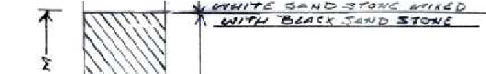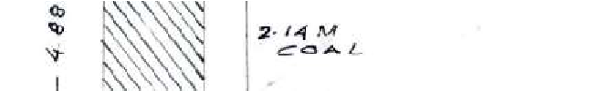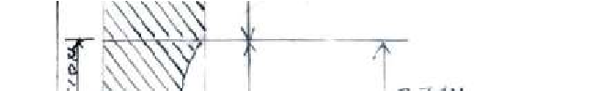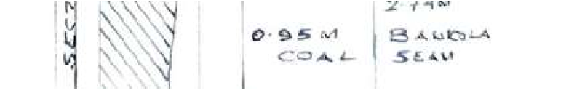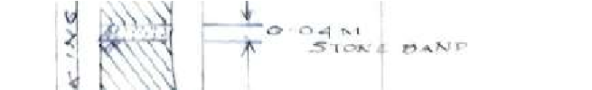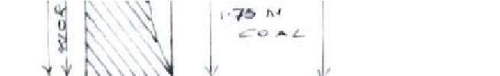

## 3. An Overview of the Mine

### 3.1 Details of Mine Openings

|  |  |  |  |  |  |
| --- | --- | --- | --- | --- | --- |
| Unit | Name of pits | Depth (metre) | Diameter  (metre) | Purpose | Type of winder |
| East Sitalpur unit | 1 pit | 68.43  Upto RVIII  B1 | 4.8 | Upcast shaft | Rubey make steam |
| 2 pit | 63.84  Upto RVIII  T2 | 4.2 | Downcast shaft  Men and material winding | Rubey make steam |
| 3 Pit | 129.91 upto  RVII 159.67 upto RVII A | 5.1 | Upcast shaft Men and material winding | Jessop make steam |
| Main incline | Upto RVII | ---- | Evacuation of coal by conveyor belt |  |

### 3.2 Degree of gassiness

|  |  |  |
| --- | --- | --- |
| Sl. No. | Seam | Degree of Gassiness |
| 1 | RVII | Deg-II |
| 2 | RVIII B1 | Deg-II |
| 3 | RVIII T2 | Deg-II |

### 3.3 Crossing point temperature and Ignition temperature

|  |  |  |
| --- | --- | --- |
| Seam | Crossing point temperature(oC) | Ignition temperature  (oC) |
| RVIII T2 | 132 | 178 |
| RVIII B1 | 132 | 178 |
| RVII | 134 | 176 |

### 3.4 Workshops and Stores

There are 3 workshop sheds and 2 stores at Shyamsundarpur colliery. Out of which 2 workshops are of E.C.L. and other one is of Joy Mining Services (JMS).

The workshop and store of JMS are under single roof spare parts are stored, repairing of equipment of continuous miner, repairing of flexible trailing cable are being carried out.

In one of the 2 workshop sheds of E.C.L repairing of electric motors; welding; cutting of TMT ribbed bar into desired sizes for roof bolting; shaping, threading of TMT bars using Lathe machine; drilling of holes in bearing plate are carried out, beside this workshop the store of E.C.L is located. And in the other working shop making of bearing plates by cutting the plates from long iron sheets using sheet cutting and forming machine; making the bearing plates dome shaped in hydraulic press are carried out.

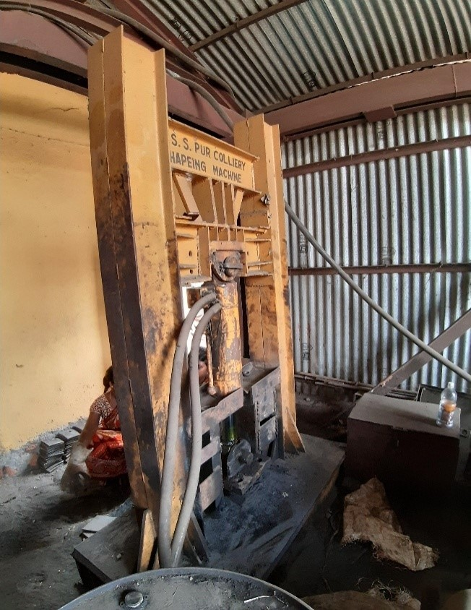

Hydraulic press to make bearing plate dome shaped

### 4. Winding Engine Room

The 3 No. pit winding engine is driven by steam which is operating at 100psi. The cut-off pressure is 70 psi. The steam generated by the boiler operating at 110 psi reaches the winding engine room through pipe lines. The brakes are operated by means of steam. The depth covered by the cage is indicated by an analog meter. There is signaling arrangement between the engine room and pit top.

4.1 Safety Devices: Is the speed goes beyond a preset limit steam supply to the engine is cut-off by means of valve; for over winding protection if the cage goes up by 1’ above the decking level steam supply to the engine is interrupted by means of vale automatically.

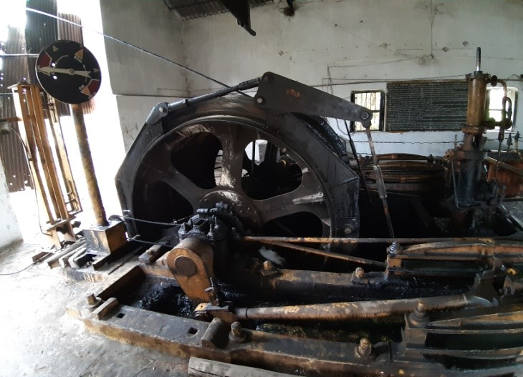

3 No. pit winding engine 4.2 Specifications of 3 No. pit Winding Engine

|  |  |
| --- | --- |
| Makers Name | JESSOP |
| Type | Steam |
| Drum Diameter | 108” |
| Brake Lining | 6’X3/4” |
| Pulley Diameter | 9’4” |
| Guide Rope Diameter | 1 “ |
| Winding Rope Diameter | 25mm |
| Life of Rope | 1 year and 6 months |
| Capacity of Suspension Gear | 5 Ton |

#### 4.3 Technical Specifications of Winding Rope

|  |  |  |  |
| --- | --- | --- | --- |
| No. 3 pit | Manufacturer | Usha Martin Limited | |
| Quality | Galvanized | |
| Construction | 6 strands | Core: 7 wire |
| Breaking Load | 326.0 KN | |
| Length of Rope | 220.0m | |
| No. 2 pit | Manufacturer | Usha Martin Limited | |
| Quality | Galvanized | |
| Construction | 6 strands | Core: 7 wire |
| Breaking Load | 326.0 KN | |
| Length of Rope | 138.0m | |

### 5. Systematic support plan

#### 5.1 Continuous Miner panel

* Size of the pillars shall not be less than 34m X 34m (centre to centre). The width and height of the galleries shall not exceed 6m and 4.5m respectively.
* Development shall be done along the floor of the seam leaving at least 0.5m of coal in the roof.
* Roof of the galleries shall be supported by 4m X 1.8m long, 22mm diameter ribbed bar, cold rolled M24 threaded and fully encapsulated high strength low viscosity resin bolts installed in 28mm diameter holes at 1.2m intervals. The support density shall be increased to 5 X 1.8m long bolts at 1.2m intervals at roadway junctions.
* The sides of pillars below Ukhra village shall be supported by three row of roof bolts in staggered fashion in such a way that the top row shall not be more than 0.5m below the roof and the distance between bolts in a row shall not exceed 2.4m and distance between rows shall not exceed 1m.

#### 5.2 LHD panel

* Support of freshly exposed roof and immediately out bye junction.
* Every development workings within 10m of face shall be supports by full column grouted roof bolts of 1.5m length placed at 1.2m X 1.2m grid pattern.
* Every junction of roadways immediately out bye of a development face shall be supported full column grouted roof bolts of 1.5m length placed at 1m X 1m grid pattern.
* The first row roof bolt shall be no more than 0.6m from the face.
* The loading point shall be supported by full column cement grouted roof bolts placed having 4 in a row at distance of 1.2m and 1.2m between the rows of bolts along the gallery and distance between bolt and side not more than 0.6m.

### 6. Man Riding Chair Lift System

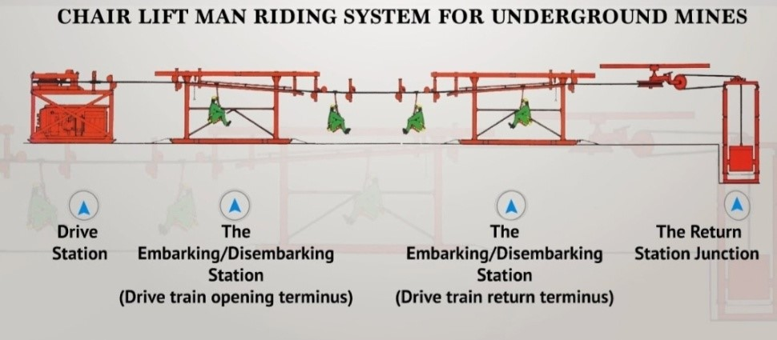

Man Riding Chair Lift System installed at pit no. 3 at Shyamsundarpur Colliery in RVII seam from 4 Level 1 East Dip to

21 Level 1 East Dip

The man riding system is presently installed from 4 Level 1 East Dip to 21 Level 1 East Dip travelling roadway. The man riding system is divide into 4 sections namely Drive station, Embarking/ disembarking system (drive train opening terminus), Embarking/ disembarking system (drive train return terminus), Return station with chain tensioning arrangement. The distance between two chairs should be at least 15m and runs at a speed of 1.15m/s. The system operates at 550V.

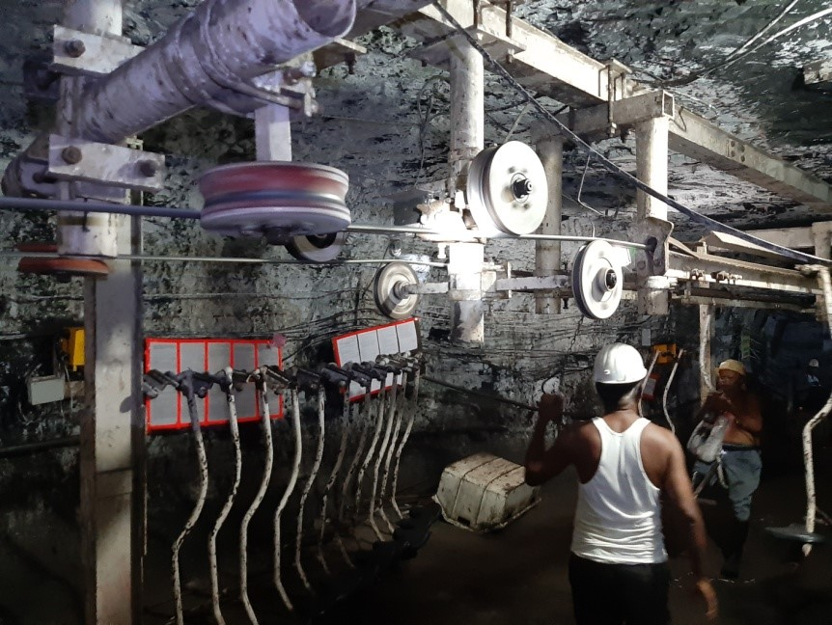

Boarding Station of Man Riding Chair Lift System at 4 Level and 1 East Dip

6.1 Safety devices installed in the Man Riding Chair Lift System

|  |  |
| --- | --- |
| Over speed tripping device | It will sense the speed of the rope. The speed of the rope crosses beyond rated speed, it senses the speed and it will cut off the Electrical power of the DC valve and the rope comes to rest. |
| Over travel tripping device | Limit switches are installed on either end of Embarking and Disembarking stations to switch off the drive when chair crosses the end position of the rail. |
| Running back stop devices | It is provided on Disembarking rail to prevent running back of chair to the rope. |
| High pressure trip | Pressure switch has been provided in Hydraulic circuit to cut-off the power to DC valve when pressure exceeds set limit. |
| High temperature trip | Temperature sensor has been provided in Hydraulic tank to cut-off power to DC valve when temperature exceeds set limit. |
| Pull cord switches | Pull cord switches along the entire length of the chair lift system installed at an interval of 45m and by using any one of the switches, the system can be stopped. |
| Counter weight switches | Switches have been provided in the guide path of the counter weight in order to stop the system when counter weight crosses the lower/upper limits. |
| Filter clog tripping | If the pressure line filter element id chocked, the switch provided will activate and cut-off power to DC valve. |
| Low oil level tripping | The micro switch provided in the indicator will activate and cutoff power when oil falls below a desired level. |

6.2 Technical specification of galvanized, non-lubricated steel wire rope

|  |  |
| --- | --- |
| Diameter | 16mm |
| Type | Lengthsway |
| Construction | 6 strand |
| Core | 7 wire |
| Breaking force | 167 kN |
| Weight per metre | 0.915 Kg/m |

6.3 Technical specification of drive unit

|  |  |
| --- | --- |
| Drive sheave diameter | 1550 mm |
| Grooved drive sheave diameter | 1480 mm |
| Brake pad dimension | 2 X 300 cm2 |
| Brake pad thickness | 25 mm |
| Brake force | 224 kN |
| Brake release pressure | 30 bar |
| Maximum pulling force | 19.64 kN |
| Working pressure | 210 bar |
| Drive speed | 0-3 m/s |

#### 6.4 Hydraulic power unit

The hydraulic power unit is to provide the hydraulic motor with the required flow of oil and pressure at the right time. All included parts are assembled in one or more compact cabinet. The Power Unit has one or more pumps driven by one or more electric motors. The main pump is an axial piston pump with variable displacement for close loop systems, Vane pump and Gear pump for open loop systems. The electric motor is totally enclosed with a sound proof canopy.

|  |  |  |  |
| --- | --- | --- | --- |
| 1 | Electric motor | 10 | Bi-metal thermometer |
| 2 | Vibration pad | 11 | Oil level  indicator |
| 3 | Bell housing | 12 | Return line filter |
| 4 | Hydraulic pump | 13 | Air breather |
| 5 | Brake block | 14 | Return line filter |
| 6 | Drain block | 15 | Oil tank |
| 7 | Manifold block | 16 | Junction box |
| 8 | Pressure relief valve | 17 | Proportional  valve drive  junction box |
| 9 | Pilot operated check valve |

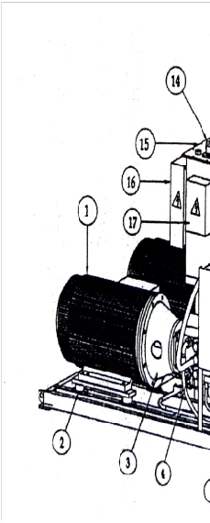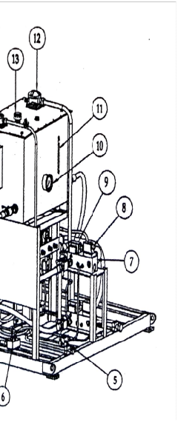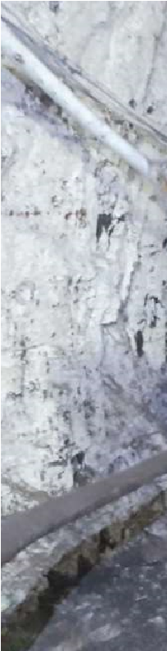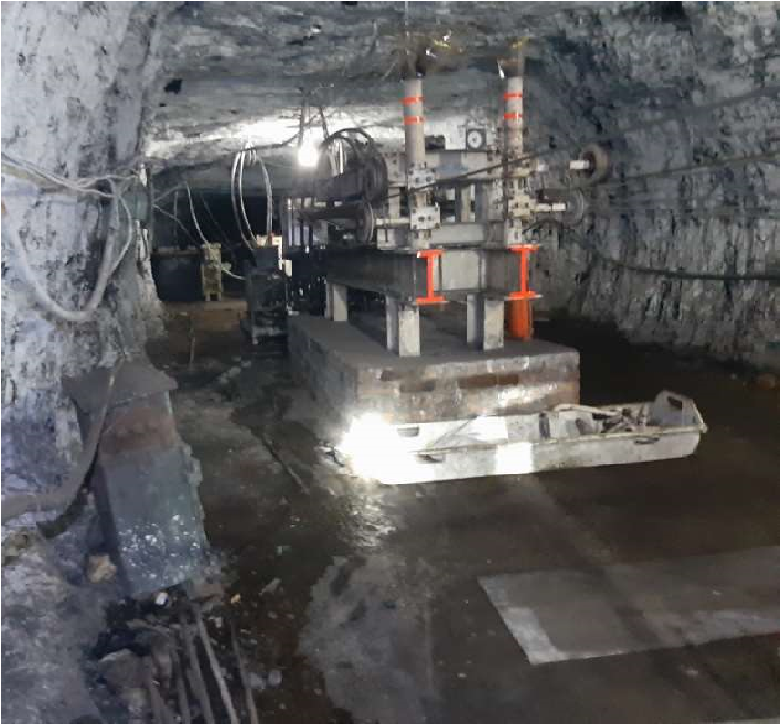

Drive Unit of Man Riding Chair Lift System

14 | P a g e

6.5 Technical specification of hydraulic power pack

|  |  |  |
| --- | --- | --- |
| Axial piston pump | | H1P 165R |
| Main pump | Fluid quantity | 165 cm3/ Rev. |
| Fluid flow rate | 240 litres/min at 1450 rpm, 50 Hz |
| Auxiliary pump | Fluid quantity | 26 cm3/ Rev. |
| Fluid flow rate | 38 litres/min at 1450 rpm, 50 Hz |
| Maximum pressure | | 420 bar |
| Maximum operating pressure | | 210 bar |
| Boost pressure | | 25 bar |
| Electric motor | | 75 kW at 1450 rpm |
| Fluid type | | HFDU 68/ HLP 68 |
| Capacity | | 300 litres |
| Other devices | | 1.Water cooler for Hydraulic fluid |
| 2. Boost pressure control switch |
| 3. Fluid level control unit |
| 4. Temperature control switch |
| 5. Operating pressure gauge |

#### 6.6 Telephone System

Loud-hailing telephone system is installed (wall mounted) between drive train opening terminus at boarding station at 4L and drive train return terminus at 21L. The system is designed to be intrinsically safe providing two ways for Duplex/ one way for Simplex communication. The model is MIC 101 PT. The intrinsically safe telephone unit has the following sub assemblies –

* Three potted electronic modules
* A re-chargeable nickel cadmium battery
* A call button
* A micropressel switch
* Twin loud speaker mounted on the body

### 7. LHD Section

Entered the LHD section through 12L

Miner Station located at the entry of the panel.

7.1 Method of working: Roof heightening was being carried out prior to depillaring by continuous miner. Holes were drilled in the roof with the help of Universal Drill Machine (UDM). Holes were charged and stemmed with P5 explosive cartridges and sand cartridges respectively. Holes are fired from RHINO-25 Shot Exploder. Prepared coal is being loaded into conveyor belt by 2 LHDs.

Prepared coal is loaded into the gate belt conveyor by LHDs.

|  |  |
| --- | --- |
| Specifications of RHINO-25 Shot Exploder | |
| Make | Electronic Equipment Manufacturing Co. |
| Limiting Resistance | 140 Ohms |
| Firing Current | 1.5 A |
| Voltage (D.C) | 500-550 |
| Discharge current duration | 3-4 m Secs. |

7.2 Gate Belt:. Width: 1200mm; PVC belt (Synthetic cotton meshing with rubber coating); double drive arrangement.

|  |  |
| --- | --- |
| Specif | ications of Drive motor |
| Make | Marathon |
| Type | 3 phase induction motor |
| Power Rating | 150 kW |
| Voltage Rating | 3300 V |
| Current Rating | 32.5 A |
| Rated Speed | 1492 RPM |

The Double drive arrangement consists of 2 induction motors each coupled with gearbox. Power is transmitted from motor shaft to gear box then to the drive drum. The drive drums rotate in opposite sense with respect to each other. The drive arrangement is adequately fenced.

7.2.1 Safety Devices in Gate Belt: Signaling arrangement; Pull chord switch installed at one or one and half pillar interval.

### 8. Continuous Miner Section

Continuous Mining technology is fully mechanized method for extraction of coal in Bord and Pillar system of mining. This technology was introduced on 28.08.2010 in RVII seam. With this technology the coal pillars are being extracted efficiently without compromising safety along with high productivity.

At present work is being carried out in Panel- 5D. The incubation period of the panel is 6 months. The panel has 25 pillars to be extracted. Gradient of the seam is 1 in 15 and thickness varied from 4.76m to 5.49m. Dip direction is S6º49´46´´E. RMR of the section is 45.5

The panel has 6 headings. In this panel the pillars are diamond shaped to facilitate machine maneuvering.

The complete system provided by Joy Mining Machinery Limited consists of the following machines:

|  |  |  |
| --- | --- | --- |
| Serial No. | Operation | Name of the Machine |
| 1 | Coal cutting and loading | Continuous Miner |
| 2 | Coal hauling | Shuttle Car |
| 3 | Coal lump breaking and feeding machine to conveyor | Feeder Breaker |
| 4 | Face supporting | Quad Bolter |
| Universal Drill  Machine |
| 5 | Power distribution | Load Centre |

8.1 Specifications of the Machinery

|  |  |  |  |
| --- | --- | --- | --- |
| Serial No. | Machinery | Model | Specifications |
| 1 | Continuous Miner | 12CM15-10VG | 585 kW, 1.1kV |
| 2 | Quad Bolter | 4XHF X280 | 125kW, 1.1kV |
| 3 | Shuttle Car | 10SC35 BC 10SC36 BC | 208 kW, 1.1kV |
| 4 | Feeder Breaker | D1MB-3-7C | 125 kW, 1.1kV |
| 5 | Load Centre | THVCMK2 TMBH | 3.3Kv/ 1.1kV; 2MVA |

Continuous Miner

The miner consists of –

* A boom carrying the cutting drum 3.3m long and 1.1m in diameter with carbide picks mounted over it.
* A gathering arm placed below the boom which loads the coal onto the flight chain
* A frame that supports the flight chain conveyor, it is movable to direct to flow of coal onto the shuttle car. ➢ Traction unit.

The miner is remotely operated by the operator standing in a safe zone out bye of the face. For suppression of dust a jet of water is directed over the cutting head.

Shuttle Cars

The continuous miner package consists of 2 shuttle cars each approximately of 8.75T capacity. The shuttle cars operate on 1.1 kV a.c. supply. The shuttle cars are tire mounted. The shuttle car has a reel drum to wind and in-wind the flexible trailing cable during the course of its movement. To load the coal uniformly and to discharge into the feeder breaker the shuttle cars equipped with a pair of Single Centre Strand armored chain conveyor.

Feeder Breaker

The feeder breaker is installed before the Gate Belt conveyor. The feeder breaker consists of lump breaker and feeder. There is arrangement of water spraying for dust suppression. The loaded shuttle car unloads the coal into the armored chain conveyor of the feeder breaker. The desired size coal is loaded into the gate belt conveyor.



Feeder Breaker

Quad Bolter

The Quad Bolter is a twin-boom four-mast crawler mounted mobile bolter with a wide range of boom movement controlled using direct mast-mounted hydraulic controls. The Quad Bolter can install four roof bolts simultaneously using two operators. In addition, the outer roof bolters can be rotated over to perform side bolting, resulting in two roof and two rib bolts at the same time. The operators always stand under a conopy during drilling and installation of roof bolts. To support the green roof there is arrangement of hydraulic support in front of the Quad Bolter. There is provision of water spraying for dust suppression; water is supplied to the machine by hoses. A reel drum is mounted on the rear end of the machine that winds and unwinds the flexible trailing cable during the course of its movement.

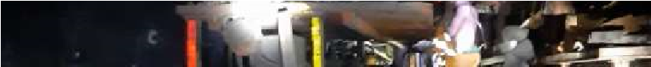

Quad Bolter performing side bolting in split

8.2 Splitting and slicing pattern

|  |  |  |  |
| --- | --- | --- | --- |
| 1 | PILLAR SIZE | Centre to Centre- 36m | Corner to Corner- 30m |
| 2 | Gallery | Width- 6.0m | Height- 4.5m |
| 3 | Split | Width- 6.0m | Height- 4.5m |
| 4 | Number of Slices | 12 | |
| 5 | Angle measure from split at which slices are driven | o  60 | |
| 6 | Width of Slices | 6.6m ; last slice of final snook 4.8m | |
| 7 | Length of Slices | 11.2m | |
| 8 | Width of Rib between Slices | 2.0m | |

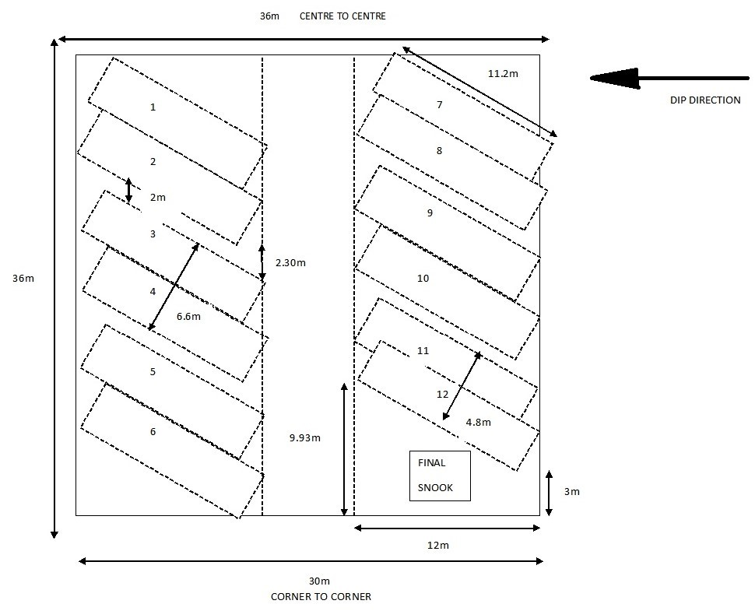

Particulars of Splitting and Slicing of pillar

8.3 Breaker Line Support

The Breaker Line Supports are installed to separate the goaf from the working area in order to prevent inadvertent access of personnel into the goaf area. The Breaker Line Support consists of 2 rows of roof bolts, 6 in each row along with “DANGER” marked tape attached to the roof bolts as well as across the gallery. An indicator prop is installed in front of the 2 rows of roof bolts to give indications of roof weighting.

#### 8.4 Auto Warning Tell-Tale Extensometer (AWTT)

AWTT is used in depillaring area. It is triggered to give indications by blinking red LED light when bed separation exceeds 5mm. In depillaring areas the front abutment pressure is very dangerous. It gives warning prior to occurrence of roof fall so that miners, machines can retreat to a safer place. In the panel 5D of RVII seam AWTTs are installed in the junctions, level galleries and splits. Before installing the AWTTs it is ensured that LEDs starts glowing and blinking when reference tube has crossed the 5mm mark on the scale.

Manufactured by Nanda Manufacturing Co.

AWTT has the following parts-

* Top anchor
* Suspension cable (10m)
* Reference tube
* Scale
* Indicator
* Ferrule

The scale is divided into 3 coloured regions-

* Green: 0-5mm
* Yellow: 5-10mm
* Red: 10-30mm

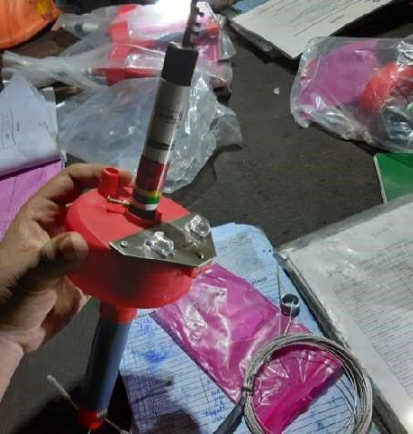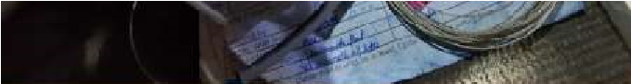

Auto Warning Tell Tale

### 9. Main Mechanical Ventilator

PV200 and PV300 mechanical ventilators are installed in the mine.

PV200 and PV300 are installed in Pit No. 01 and Pit No. 03 respectively.

|  |  |
| --- | --- |
| Spe | cifications of PV200 |
| Make | VOLTAS |
| Type | AXIAL |
| Fan Capacity | 5000 m3/h |
| Fan Speed | 750 |
| Water Gauge | 33 mm |
| Power Rating | 90 kW |
| Voltage Rating | 550 V |

|  |  |
| --- | --- |
| Spe | cifications of PV300 |
| Make | VOLTAS |
| Type | AXIAL |
| Fan Capacity | 8000 m3/h |
| Fan Speed | 750 |
| Water Gauge | 52 mm |
| Power Rating | 300 kW |

# 10.Coal Handling Plant

Coal from underground via the trunk belt installed along the main incline is discharged on to the conveyor belt of the CHP by means of chute, two drives are installed on ground to drive the conveyor belt of the CHP. The specification of the drive is given below:

|  |  |
| --- | --- |
| Number of motors | 2 |
| Power rating | 55 kW |
| Voltage rating | 415 V |
| Rated speed | 1478 |
| Gear box | Premium helical gear box |
| Width of conveyor belt | 1200mm |
| Length of conveyor belt | 300m |

The conveyor belt of the CHP goes through a Motorised Travelling Tripper (MTT) mounted on rails; the MTT moves over the bunker in which coal is to be discharged and flow of coal into bunker of CHP is directed and controlled by Motorised Flap Gate. There is arrangement of water spraying for suppression of coal dust. There are 4 bunkers of the CHP. The plant is capable of handling 750 TPH of coal. Coal from bunkers is loaded into dumpers by controlling the Manual Sector Gate.

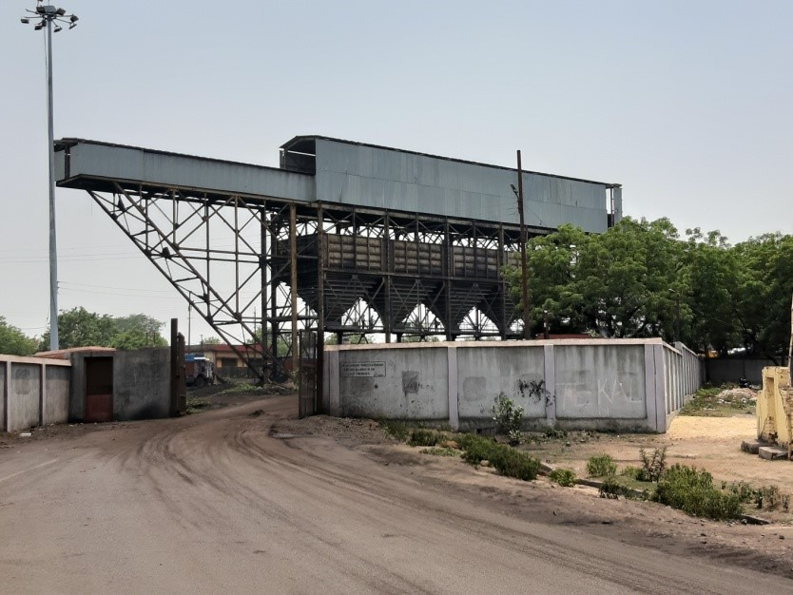

750 Ton per Hour capacity Coal Handling Plant